Possible relationship between unemployment and inflation

- Discuss, using a short-run Phillips curve diagram, the view that there is a possible trade-off between the unemployment rate and the inflation rate in the short run.
  - Copy and use Figures 18.8 and 18.9 (p239) to explain the inflation/unemployment trade-off
  - Explain the implications of these diagrams for government policy makers

- Explain, using a diagram, that the short-run Phillips curve may shift outwards, resulting in stagflation (caused by a decrease in SRAS due to factors including supply shocks).
  - (do this)

- Discuss, using a diagram, the view that there is a long-run Phillips curve that is vertical at the natural rate of unemployment and therefore there is no trade-off between the unemployment rate and the inflation rate in the long run.
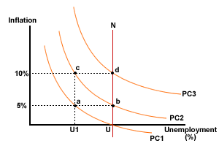
Figure 1 Long-run Phillips curve

In figure 1 above, assume that unemployment is initially at the natural rate U, i.e. the economy is operating at f______ employment. Also assume that the government believes a rate of unemployment of U to be too high, and attempts to reduce it to U1 by expansionary monetary and f_____ policies. The following steps will occur:
- Step 1 – AD increases… increased d______ for labour… increased w______, i.e. the economy now moves to point a, with 5% inflation and reduced unemployment in the short run as workers who had not been prepared to take jobs at existing wage levels are attracted by what they think are higher wages – but the increase in the price level has reduced r______ wages…workers have suffered from money illusion
- Step 2 – workers realise their real wages have not risen and demand h______ wages, firms respond by laying off some of their now more costly workers and unemployment goes back to the natural rate at U… but at a new expected rate of inflation of 5%... a movement from a to b on a new higher short-run Phillips Curve, PC2
- Step 3 - at point b, i_________ is 5% and unemployment has returned to the U. If the government wishes to reduce unemployment again to U1 by increasing government spending, it will result in a 10% inflation rate at point c on PC2
- Step 4 - again the same process is followed as workers learn to anticipate the inflation rate, with a return to the natural rate at point d on a new short-run P_________ curve PC3, the same level of u_____________ but with an inflation rate of 10%

So, the long-run Phillips curve is v__________ at the natural rate of unemployment, U. There is no long run trade-off between inflation and unemployment, the implication being that governments cannot permanently reduce unemployment below the natural rate by reflationary m___________ and fiscal policies. Any time unemployment falls below the natural rate, inflation forces workers to demand higher wages, which leads firms to cut back on hiring until unemployment has once again increased to the natural rate.

Task: Use the diagram below to explain the process if unemployment increases above the natural rate.
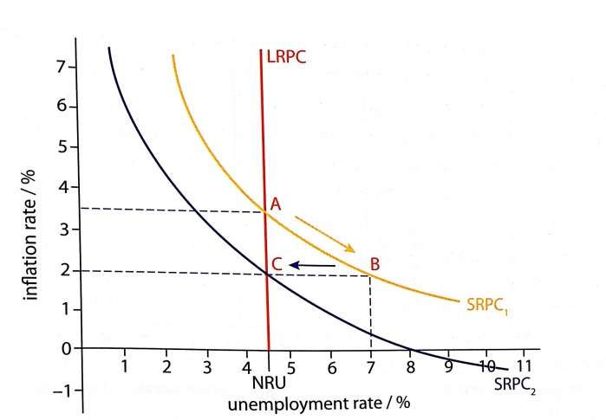

- Explain that the natural rate of unemployment is the rate of unemployment that exists when the economy is producing at the full employment level of output.

The natural rate of unemployment is the unemployment that occurs when the economy is at full employment and the labour market is in e_____________, i.e. the only unemployment that exists is f____________, seasonal and s_________________.
What determines natural rate and how can it be reduced?
The natural rate of unemployment cannot be defined as some percentage of the labour force. It depends on a number of factors which are liable to change over time. For example:
- Technology and information
- Comparative advantage and international trade
- The degree of occupational and geographical mobility
- Information regarding job opportunities
- Restrictive practices imposed by trade unions
It would therefore follow that the natural rate of unemployment could be reduced by removing 'frictions' or obstacles to supply. This could be achieved by various supply-side measures, such as:
- Reducing the power of trade _______ to resist reductions in real wages and to impose minimum wage rates (i.e. unions should be made more docile and accepting of the conditions which owners of capital wish to impose on them!).
- A combination of reduced b________ and lower t_______ to induce the unemployed to take lower paid jobs.
- Increasing ____________ and ____________ mobility (e.g. with retraining).
- Establishing an efficient system of i_____________ flows.
Copy Figure 18.11 to show reduction in LR Phillips Curve and explain the link between LRPC and LRAS

