Comparative advantage theory

International trade is based on the theory of comparative advantage which in turn is based on the concept of opportunity costs.

Absolute advantage=

Comparative advantage=

Assumptions:
- No transport costs
- Costs are constant (no economies of scale)
- Factors of production are perfectly mobile
- No barriers to trade
- Perfect knowledge (all buyers and sellers know where the cheapest goods can be found internationally)
- Traded goods are homogenous

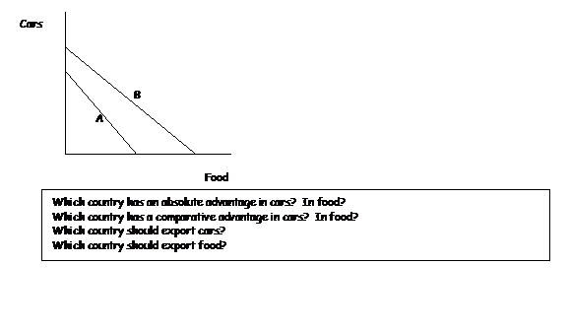
Comparative advantage for the best producer (B) is with the product for which the difference between the PPFs is the greatest, ie. food

Comparative advantage is a principle of economics which states that trade between TWO countries will be MUTUALLY beneficial as long as their domestic opportunity costs of production differ. Countries will be able to consume beyond their own PPCs.

The terms of trade (ratio of export prices to import prices) will determine whether trade is advantageous to a country.
Example: | Nauru 1P = 1C
 | Tarawa 1P = 2C

- trade will take place if the price of 1 tonne of phosphate lies between 1 tonne of coconuts and 2 tonnes of coconuts (1C < 1P <2C), i.e. in this case 1P=1.25C. Nauru sells phosphate at more than it cost them to produce and Tarawa buys phosphate for less than it could produce themselves
- the price ratio must lie somewhere between the 2 countries PPCs

